GOVERNMENT DEGREE COLLEGE, GUMMALAKSHMIPURAM
DEPARTMENT OF HISTORY 2024-25
Name of the Event: Adivasee Diwas (World Indigenous)
Guest of Honor : V. Kalpana (In charge - Principal)
Date : 09-08-2024
Department : History
Lecturers Attended: 08
Students Attended: 30

The world indigenous people day was celebrated in The College Aug -09-2023. The guest of honor Smt. V. Kalpana in charge Principal of this college. Delivered a Message on the importance of that day celebration etc, all the staff and students participated in this program. Cultural Activities are also staged By the Students among which DHIMSA got full appreciation Prizes were distributed to the students on the Independence Day.
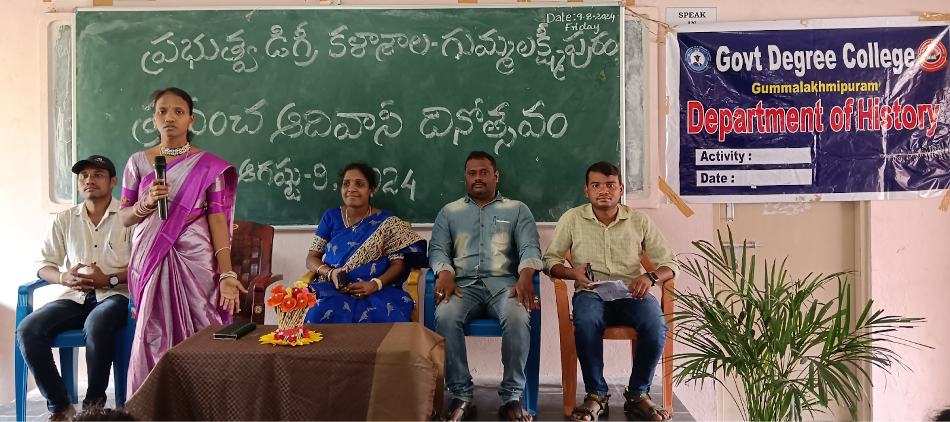
Speech given by Lecture in History A. Srivani
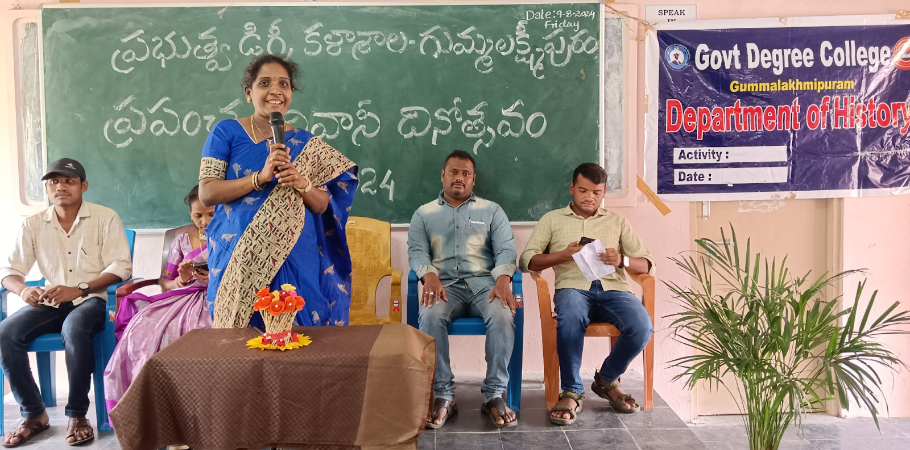
Speech given by IQAC Coordinator V. Kalpana
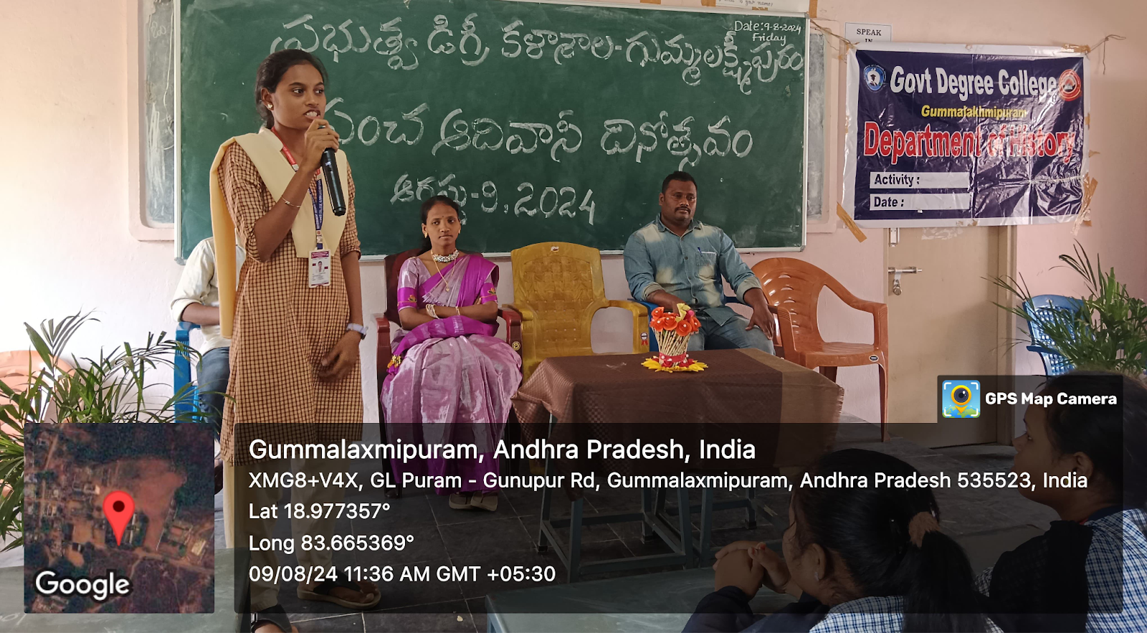
Speech Given by Student T. Srija
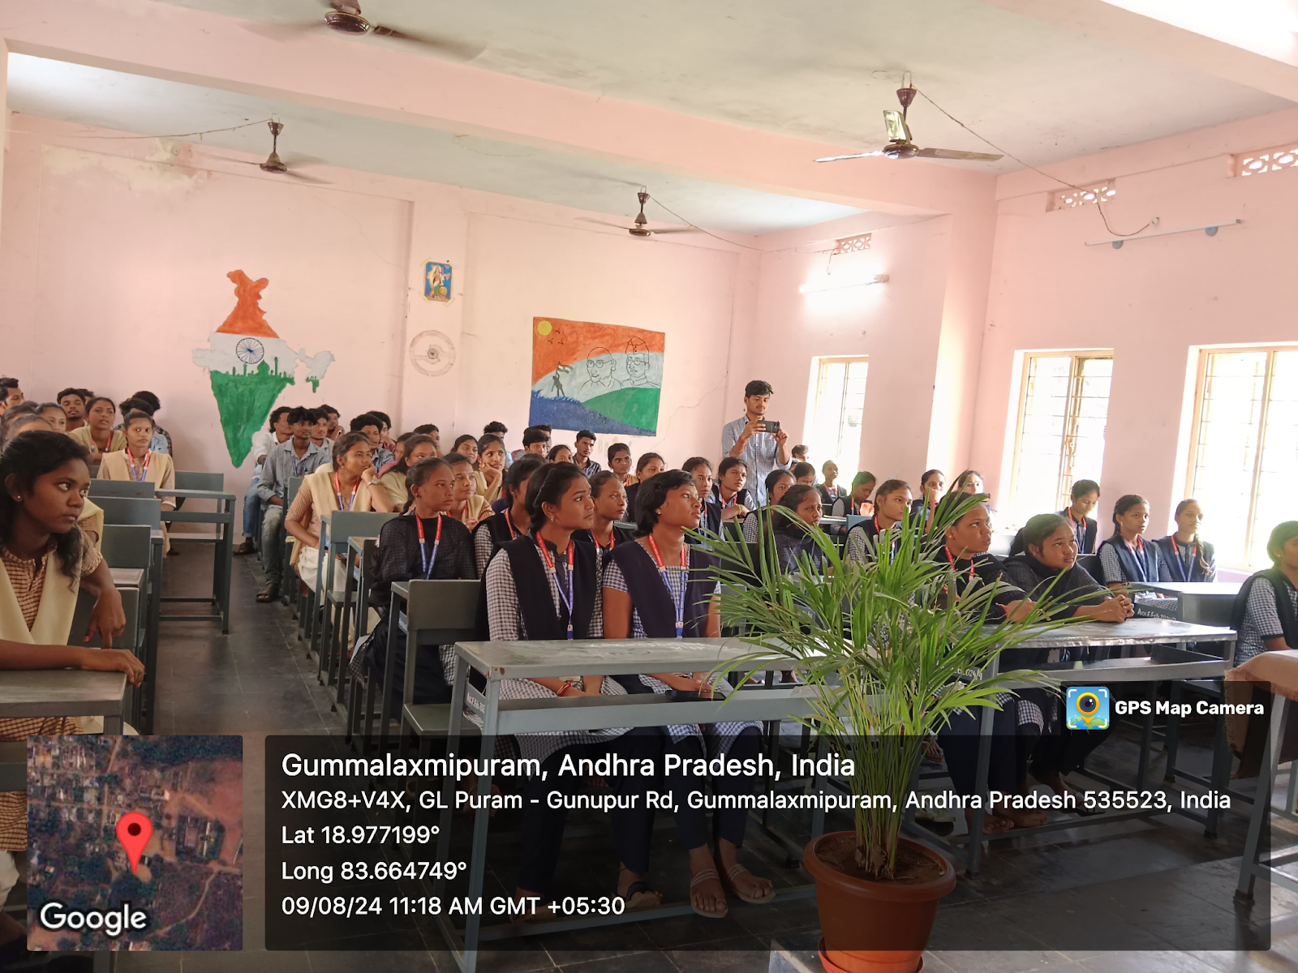
Conclusion for Indigenous Peoples' Day
As we conclude today's observance of Indigenous Peoples' Day, let us remember that the history, culture, and contributions of Indigenous peoples are integral to the fabric of our societies. Today is not just a day to honor the past but to acknowledge the ongoing struggles and resilience of Indigenous communities around the world. It is a reminder that we must continue to listen, learn, and support efforts to protect Indigenous rights, traditions, and lands.
Let us commit to standing in solidarity with Indigenous peoples, ensuring their voices are heard, their stories are respected, and their future is safeguarded. The path to justice and equality begins with understanding, respect, and a shared responsibility to create a world where all cultures and peoples are celebrated.

Thank you.

